AODA ONLINE TRAINING STEP-GUIDE

- In order to begin, you will be asked to enter your McMaster ID and password. If you do not have a Mac ID please speak with your supervisor.

The training consists of three components that you will need to complete.

You must first register for the training in Mosaic by logging in with your McMaster ID and password.

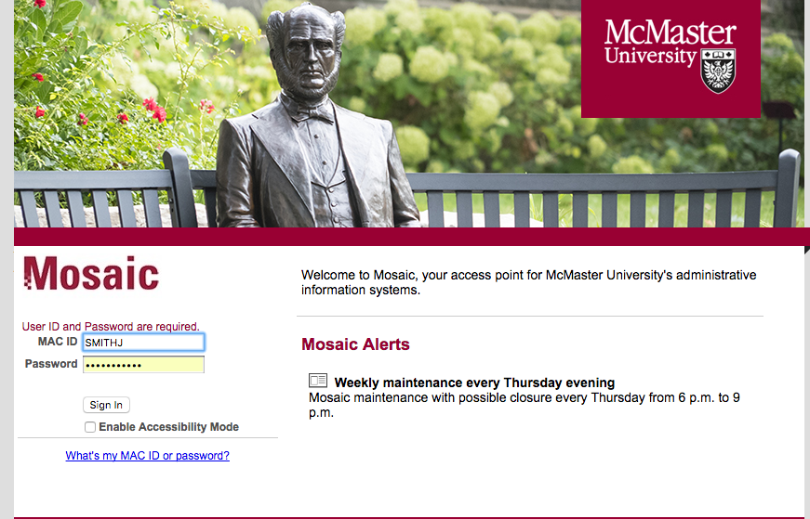

- In the Home tab, select the 5th square (beginning from the top left corner) titled Health and Safety Training, AODA, Privacy and Regulatory training.

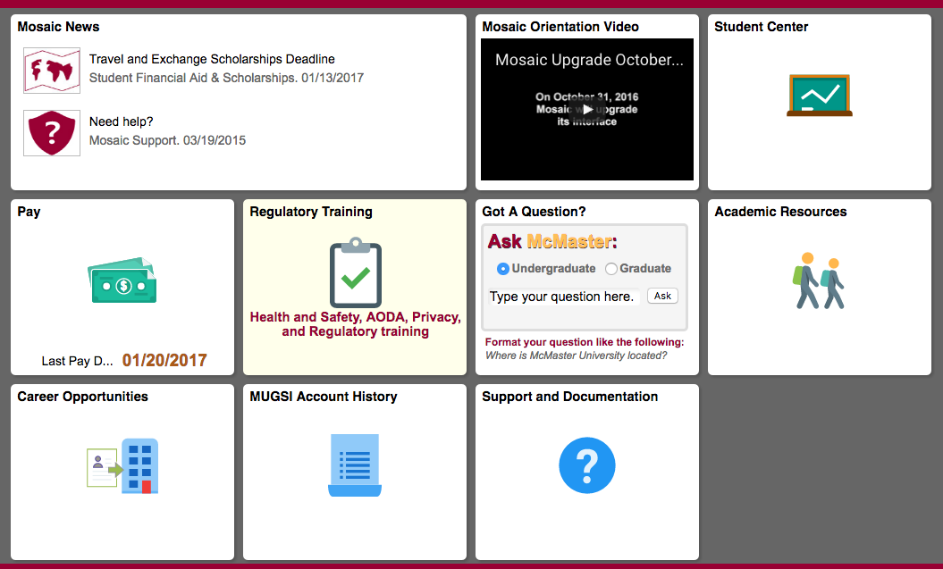

- Then Search by Course Name by typing AODA in the search bar. You will see selections for “AODA and Human Rights Code” and “AODATL: Accessible Education”. Select “AODA and Human Rights Code”.

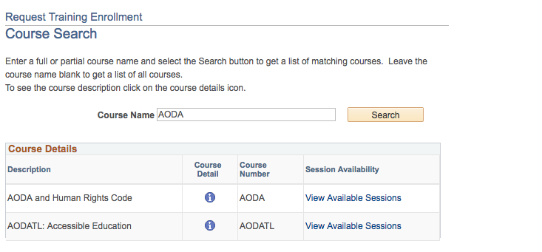

- Click on View available session, then select Session #### to get to the registration page. On the next page click on Continue in order to request your registration in the course.

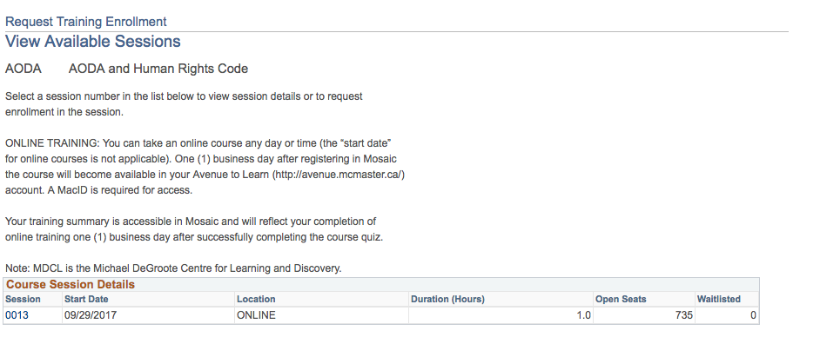

NOTE: Please disregard the session’s start date, end date, start time and end time, as they are just references for administrative purposes.
You can complete the training at any time after you register.

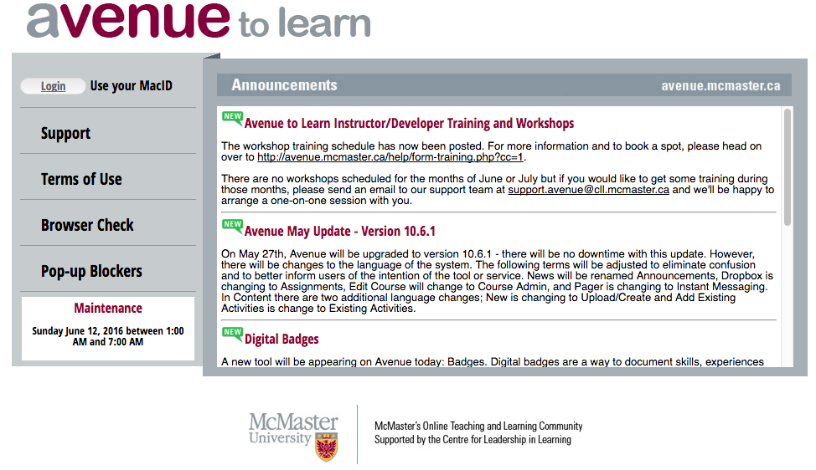

- After completing this step, the course content and quiz will become available to you on AvenuetoLearn 15 minutes after registration. Login to Avenue to Learn with your McMaster ID and password.

- Under Continuing you will see AODA and Human Rights Code. Click on this title and you will be able to begin your required. training.

- The training consists of 5 short videos and a quiz, which you need to complete in order to successfully complete the training. Within this training, you will review:
- AODA and Human Rights Code: Who are people with disabilities at McMaster?
- AODA and Human Rights Code: What is accessibility at McMaster?
- AODA and Human Rights Code: Summary of Accessibility Requirements at McMaster University
- AODA and Human Rights Code: Be an Accessibility Ambassador
- AODA and Human Rights Code: Ableism

- Once the quiz is successfully completed, you will be able to see your grade in AvenuetoLearn under Assessments Grades for 24 hours. After this time, a record of your results will be made available to you on Mosaic one (1) business day after completion.

NOTE: You will NOT receive a confirmation email on your McMaster email. Results will be available on Mosaic.

For more information about the AODA Training Modules please contact the Accessibility Projects Assistant at aoda@mcmaster.ca

