ACCESSIBLE EDUCATION ONLINE TRAINING STEP-GUIDE
The training consists of three steps that you will need to complete:
- Registering in Mosaic;
- Reading the FLEX Forward e-book;
- Completing the end quiz on Avenue to Learn.

Part 1: Registering in Mosaic
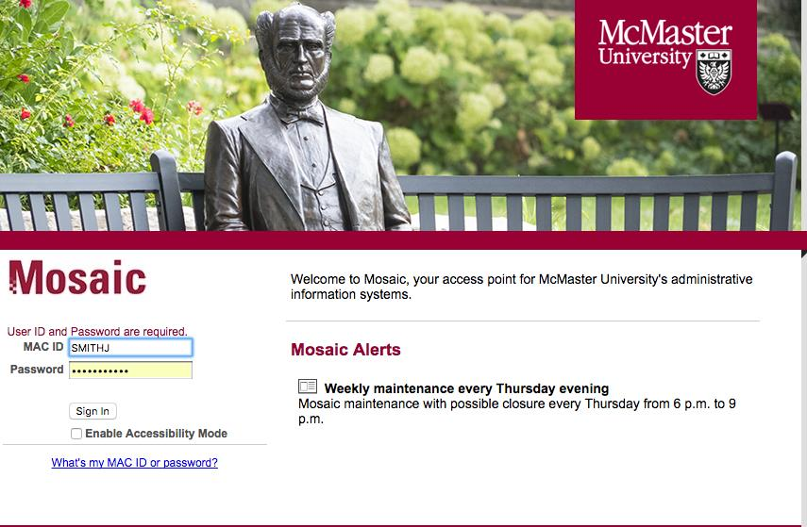
- You must first register for the training in Mosaic by logging in with your McMaster ID and password. If you do not have a Mac ID, please speak with your supervisor.

- In the Home tab, select the square titled Health and Safety Training, AODA, Privacy and Regulatory training.
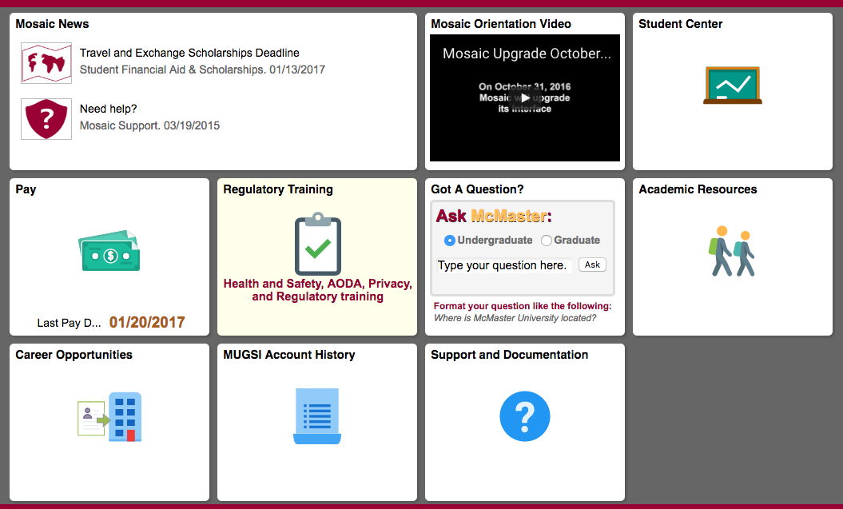
- Click Search by Course Name, type AODA in the search bar, press Search.

- Find the “AODATL: Accessible Education” option and click on View available sessions. Select Session 0001 to get to the registration page.
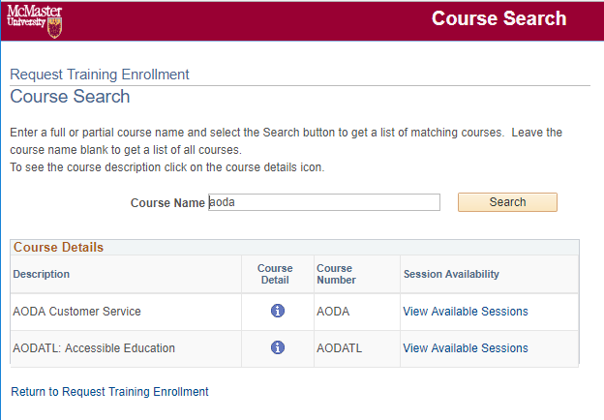

- On the next page, click on Continue in order to request your registration in the course.
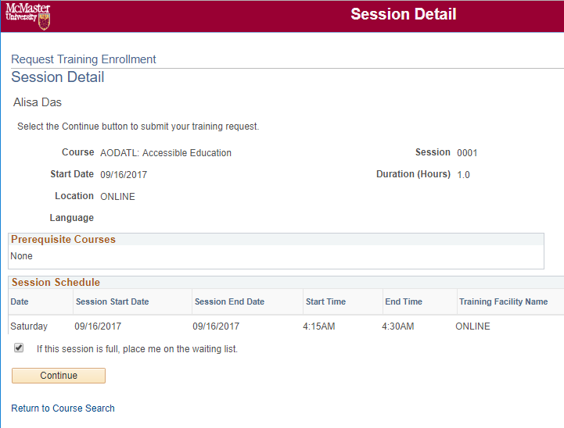

NOTE: Please disregard the session’s start date, end date, start time and end time, as they are just references for administrative purposes. You can complete the training at any time after you register.
- Click Submit on the following page. After completing this step, the course content and quiz will become available to you on Avenue to Learn 24 hours after registration.

Part 2: Reading the FLEX Forward E-Book
- Visit the link http://flexforward.pressbooks.com.

- Click Read and flip your way through the book.
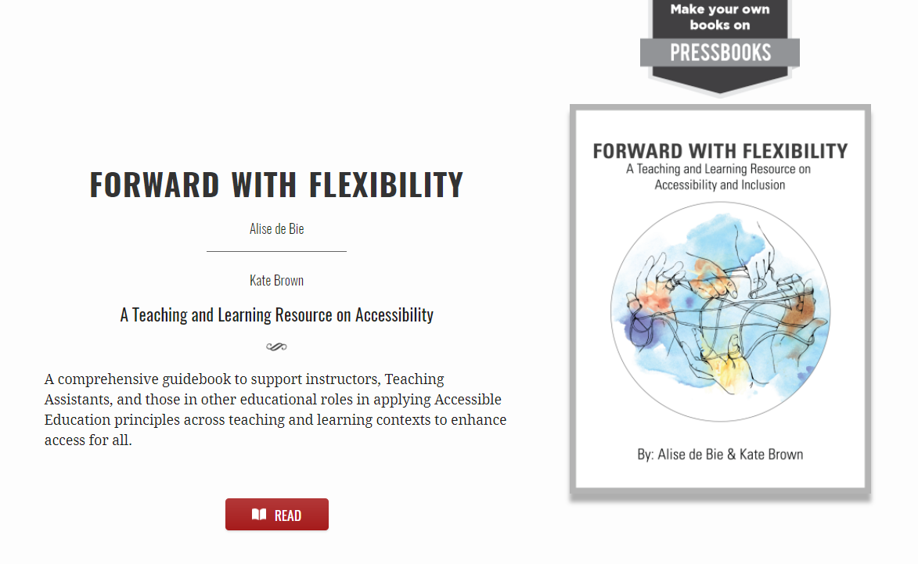

Part 3: Completing the End Quiz in Avenue to Learn
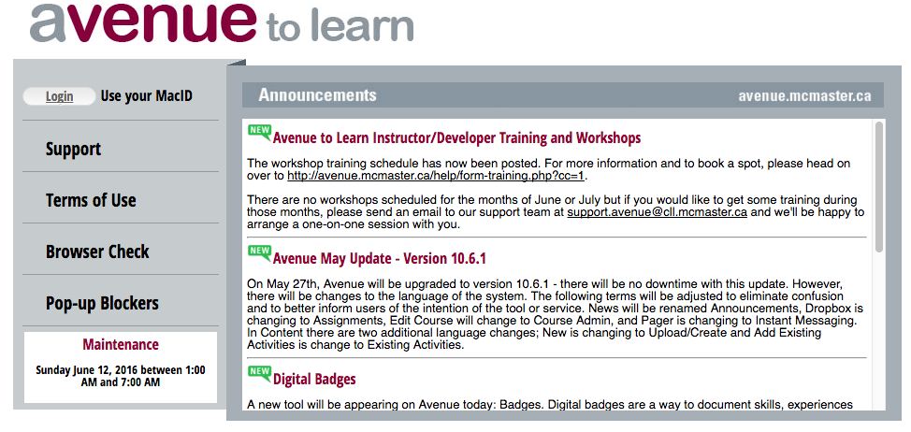
- Login to Avenue to Learn with your McMaster ID and password.

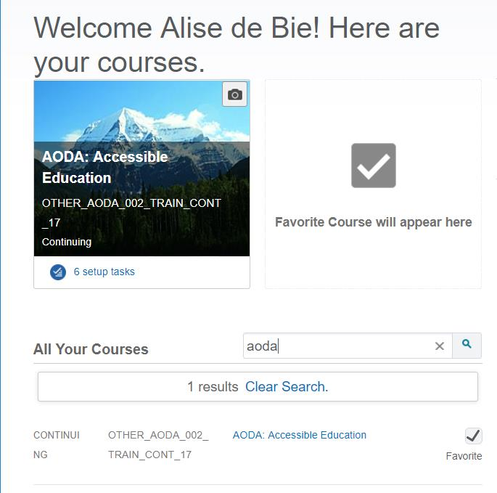
- Search your Avenue to Learn courses by typing AODA in the search bar on the first page. Click to enter the course shell.

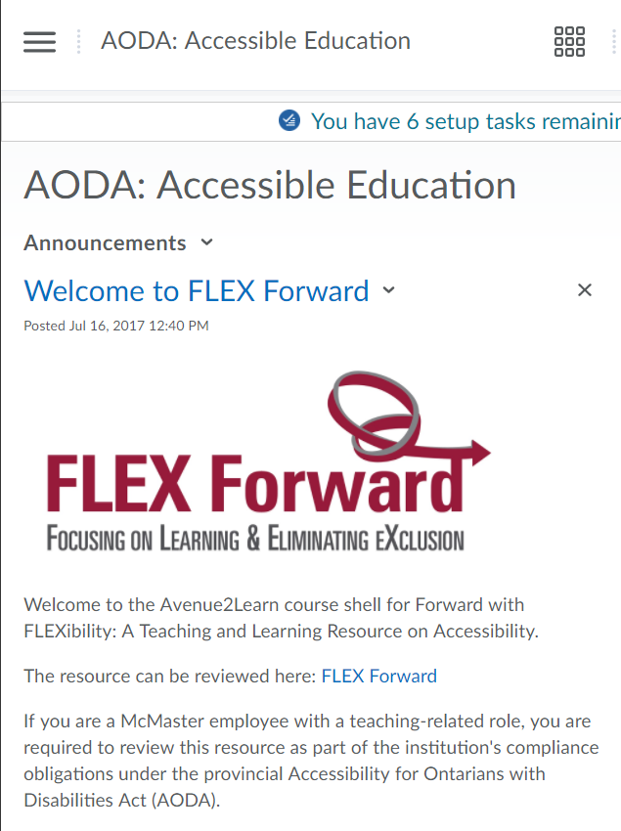
- On the top left-hand side of the screen, click the pattern with 3 horizontal lines.

- Click Assessments, then Quizzes.
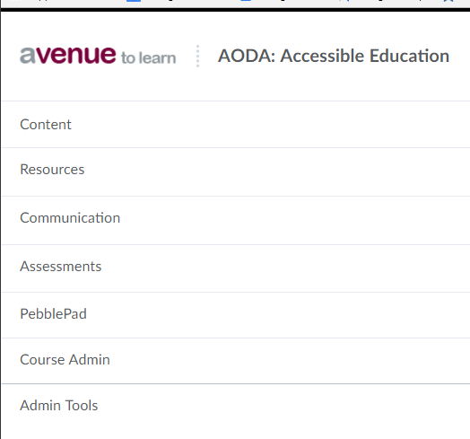
- Select and click through to complete the quiz.
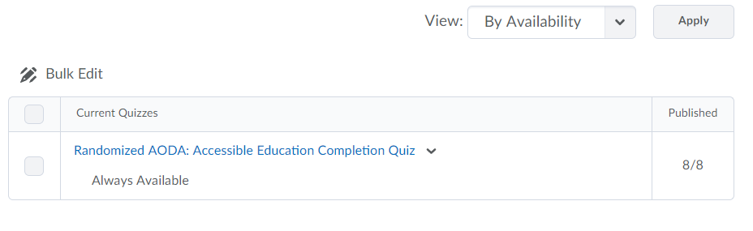
- Once the quiz is successfully completed, you will be able to see your grade in Avenue to Learn under Assessments Grades.
Within 1 business day, your results will be transferred back to Mosaic.
NOTE: You will NOT receive a confirmation email on your McMaster.

