CHECKING YOUR AODA ONLINE TRAINING RESULTS

- Login to Mosaic with your McMaster ID and password.

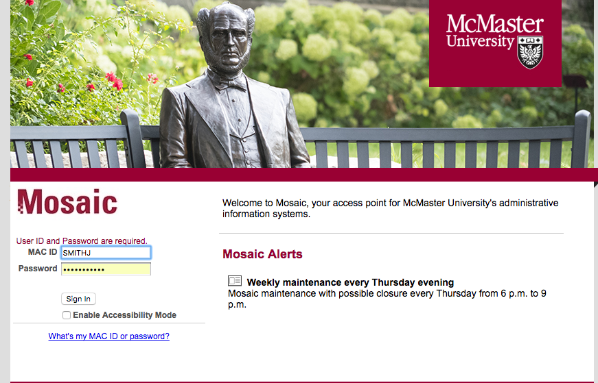

- In the Home tab, select the 5th square (beginning from the top left corner) titled Health and Safety, AODA, Privacy and Regulatory training.

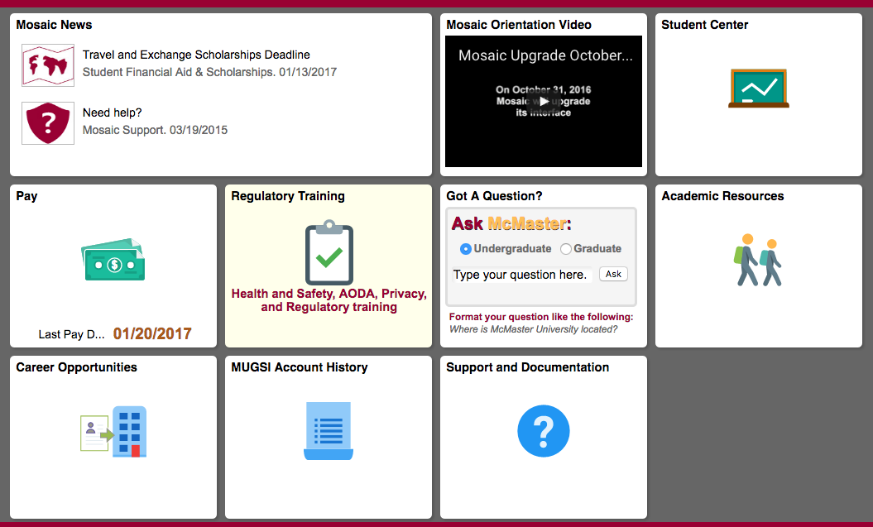
- Under Request Training Enrollment click on Training Summary for your results
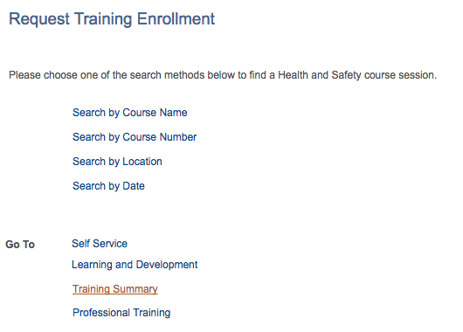

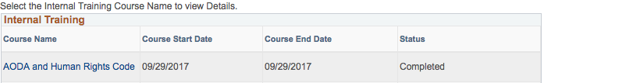
- On this page you will get access to your training summary and status for future references.

For more information about the AODA Training Modules please contact the Accessibility Projects Assistant at aoda@mcmaster.ca

